Q.1 What are Type I and Type II errors in hypothesis testing, and how do they impact decision-making?
Ans. When conducting a hypothesis test, you are testing a null hypothesis ($H_0$) against an alternative hypothesis ($H_a$). Since hypothesis testing relies on sample data, there is always a risk of making an incorrect decision. The two main types of errors are Type I and Type II errors.
📝 Type I and Type II Errors
Decision | H0​ is TRUE (No effect/difference) | H0​ is FALSE (Effect/difference exists)
Reject $H_0$ (Conclude effect exists) | Type I Error (False Positive, $\alpha$) | Correct Decision (Power, $1-\beta$)
Fail to Reject $H_0$ (Conclude no effect exists) | Correct Decision (Specificity, $1-\alpha$) | Type II Error (False Negative, $\beta$)

Type I Error (False Positive) 🚨
A Type I Error occurs when you reject a true null hypothesis ($H_0$).
- Definition: Concluding that there is a significant effect or difference when, in reality, there is none.
- Probability: The probability of committing a Type I error is denoted by $\alpha$ (alpha), which is also known as the significance level. Researchers set this level (commonly $\alpha = 0.05$ or 5%) to control the risk of this error.
- Analogy: Convicting an innocent person in a legal trial (where $H_0$ is "defendant is innocent").
Type II Error (False Negative) 🚫
A Type II Error occurs when you fail to reject a false null hypothesis ($H_0$).
- Definition: Concluding that there is no significant effect or difference when, in reality, one actually exists. You miss a true effect.
- Probability: The probability of committing a Type II error is denoted by $\beta$ (beta). The power of a test is $1 - \beta$, which is the probability of correctly rejecting a false null hypothesis.
- Analogy: Acquitting a guilty person in a legal trial.

🎯 Impact on Decision-Making
The choice of the significance level ($\alpha$) and the resulting risk of a Type I or Type II error significantly impacts decision-making, as there is often a trade-off between the two:
- Decreasing the risk of a Type I Error ($\alpha$) (e.g., changing $\alpha$ from 0.05 to 0.01) will, all else being equal, increase the risk of a Type II Error ($\beta$).
- Increasing the statistical power ($1-\beta$) to reduce the risk of a Type II Error (e.g., by increasing the sample size) can, in some cases, increase the risk of a Type I Error.
Decision-makers must weigh the consequences of each error type in their specific context and choose a balance that minimizes the more costly mistake.
- High Cost for Type I Error: If a false positive is dangerous or very expensive (e.g., falsely concluding a new drug works and approving it, or a false fire alarm in a critical facility), you would choose a low $\alpha$ (e.g., 0.01).
- High Cost for Type II Error: If a false negative is dangerous or costly (e.g., missing a disease diagnosis, or failing to detect a critical security vulnerability), you would prioritize high power ($1-\beta$) and a lower $\beta$.

Q.2 What is the P-value in hypothesis testing, and how should it be interpreted in the context of the null hypothesis?
Ans. The P-value is a fundamental concept in hypothesis testing. It is the metric used to decide whether to reject the null hypothesis.¹
What is the P-value? 🤔
The P-value (or probability value) is the probability of observing a test statistic as extreme as, or more extreme than, the one calculated from your sample data, assuming that the null hypothesis (²$H_0$) is true.³
In simpler terms:
- It measures how likely your data would be if there were actually no effect or no difference (i.e., if $H_0$ were correct).
- A small P-value suggests your observed data is very unlikely under the assumption of the null hypothesis.⁴
- A large P-value suggests your observed data is quite likely under the assumption of the null hypothesis.

Interpreting the P-value in Context 📊
The P-value is compared against the significance level (⁵$\alpha$), which is the pre-determined threshold for deciding statistical significance (often set at 0.05).⁶
1. If P-value $\le \alpha$ (Small P-value)
- Interpretation: The observed data is considered unlikely if ⁷$H_0$ were true.⁸
- Decision: You reject the null hypothesis (⁹$H_0$).¹⁰
- Conclusion: You have sufficient statistical evidence to support the alternative hypothesis (¹¹$H_a$), concluding that a significant effect or difference exists.¹²
Example: If $\alpha = 0.05$ and your P-value is $0.01$, you reject $H_0$. There is only a 1% chance of seeing your data if $H_0$ were true, which is lower than the 5% risk ($\alpha$) you were willing to accept for a Type I error.
2. If P-value $> \alpha$ (Large P-value)
- Interpretation: The observed data is considered likely or reasonably probable if $H_0$ were true.
- Decision: You fail to reject the null hypothesis (¹³$H_0$).¹⁴
- Conclusion: You do not have sufficient statistical evidence to support the alternative hypothesis ($H_a$). You are not concluding that $H_0$ is true, but simply that the data does not provide enough evidence to reject it.
Example: If $\alpha = 0.05$ and your P-value is $0.25$, you fail to reject $H_0$. There is a 25% chance of seeing your data if $H_0$ were true. Since this is greater than 5%, you don't consider the data unusual enough to reject the assumption that $H_0$ is correct.

Key Points and Common Pitfalls
Point | Description
It is NOT the probability that $H_0$ is true. | The P-value assumes $H_0$ is true. It measures the evidence against $H_0$.
It does NOT measure the size of the effect. | A very small P-value only means the effect is unlikely to be zero; it doesn't mean the effect is large or practically important. This is known as practical significance vs. statistical significance.
It is context-dependent. | A P-value must always be interpreted in the context of the specific hypothesis being tested, the chosen $\alpha$ level, and the potential consequences of the decision.

Q.3 Explain the difference between a Z-test and a T-test, including when to use each.
Ans. The Z-test and T-test are both parametric hypothesis tests used to determine if the means of two data sets are significantly different.¹ The key distinction between them lies in the knowledge of the population standard deviation and the size of the sample.²
⚖️ Key Differences: Z-test vs. T-test
The choice between a Z-test and a T-test is primarily driven by two factors: the Population Standard Deviation (³$\sigma$) and the Sample Size (⁴$n$).⁵
Feature | Z-test | T-test
Population Standard Deviation ($\sigma$) | Known | Unknown (Estimated from sample as $s$)
Sample Size ($n$) | Large ($n \ge 30$) | Small ($n < 30$)
Test Distribution | Z-distribution (Standard Normal Distribution) | t-distribution (Student's t-distribution)
Degrees of Freedom (DF) | Not applicable (Distribution is fixed) | Required ($\text{DF} = n - 1$ for one sample)
Formula (One-Sample) | $$Z = \frac{\bar{x} - \mu_0}{\sigma / \sqrt{n}}$$ | $$t = \frac{\bar{x} - \mu_0}{s / \sqrt{n}}$$
- $\bar{x}$ is the sample mean.⁶
- $\mu_0$ is the hypothesized population mean.⁷
- $\sigma$ is the population standard deviation.⁸
- $s$ is the sample standard deviation.⁹
- $n$ is the sample size.¹⁰

🎯 When to Use Each Test
Z-test: For Known Variance and Large Samples
The Z-test is appropriate when you have enough information to treat your test statistic as being normally distributed, specifically when:
- The population standard deviation (¹¹$\sigma$) is known.¹² This is often the case in quality control or when using well-established measurements where historical data provides a reliable population variance.
- The sample size (¹³$n$) is large (¹⁴$n \ge 30$). Due to the Central Limit Theorem, for sufficiently large samples, the sampling distribution of the mean will be approximately normal, even if the population standard deviation is unknown.¹⁵ In this common scenario, you use the sample standard deviation ($s$) as a good estimate for $\sigma$, but you still use the Z-distribution.
T-test: For Unknown Variance and Small Samples
The T-test is more common in research because the population standard deviation is usually unknown.¹⁶ The t-distribution is used to account for the extra uncertainty that arises from having to estimate the population standard deviation from the sample data.¹⁷ This extra uncertainty is more pronounced with small samples.¹⁸
- The population standard deviation (¹⁹$\sigma$) is unknown.²⁰ The test must rely on the sample standard deviation ($s$).
- The sample size (²¹$n$) is small (²²$n < 30$).²³
The t-distribution has "heavier tails" than the Z-distribution (the standard normal distribution), meaning it assigns a higher probability to extreme values.²⁴ This accounts for the increased risk of error when working with small samples.²⁵ As the sample size ($n$) increases, the t-distribution approaches the Z-distribution, which is why the T-test is used for smaller samples.

🛠️ Summary of Application
Scenario | Test to Use | Rationale
$\sigma$ Known, $n \ge 30$ | Z-test | All assumptions for Z-distribution are met.
$\sigma$ Known, $n < 30$ | Z-test | Knowledge of $\sigma$ is the primary determinant.
$\sigma$ Unknown, $n \ge 30$ | Z-test | Large sample size allows use of $s$ to approximate $\sigma$, and the Central Limit Theorem applies.
$\sigma$ Unknown, $n < 30$ | T-test | Unknown $\sigma$ and small $n$ necessitate the use of the t-distribution to account for uncertainty.

Q.4 What is a confidence interval, and how does the margin of error influence its width and interpretation?
Ans. A confidence interval (CI) is a range of values used to estimate an unknown population parameter (like the population mean, μ) based on a sample statistic (like the sample mean, xˉ).
It provides a level of certainty, known as the confidence level (e.g., 95% or 99%), that the interval calculated from the data contains the true population parameter.

🧭 Interpreting a Confidence Interval
The formula for a confidence interval is:
CI=Sample Statistic±Margin of Error
For example, if you calculate a 95% confidence interval for the average height of students to be (168 cm,172 cm), the correct interpretation is:
We are 95% confident that the true average height of the entire population of students falls between 168 cm and 172 cm.
Crucial Interpretation Point: The confidence level refers to the method itself. If you were to repeat the sampling and interval calculation process many times, the confidence level (e.g., 95%) is the percentage of the resulting intervals that would actually contain the true, fixed population parameter. It is incorrect to say there is a 95% probability that the true mean falls within this specific calculated interval.

📏 The Margin of Error and Interval Width
The Margin of Error (ME) is the ± amount added to and subtracted from the sample statistic. It quantifies the amount of sampling error that can be expected and represents the radius (half the width) of the confidence interval.
Margin of Error (ME)=Critical Value×Standard Error
The width of the confidence interval is equal to 2×Margin of Error.
Influence on Width
The margin of error directly determines the width of the confidence interval.
- Larger Margin of Error → Wider Interval
- Smaller Margin of Error → Narrower Interval
Influence on Interpretation
The margin of error helps balance certainty and precision in your estimate:
Factor | Effect on Margin of Error | Effect on Interval Width | Effect on Interpretation
Increased Confidence Level (e.g., 90% to 99%) | Increases ME (Larger Critical Value) | Wider | Higher Certainty (More likely to capture the true parameter, but less precise).
Increased Sample Size (n) | Decreases ME (Smaller Standard Error) | Narrower | Higher Precision (More useful estimate, as you have more information).
Increased Data Variability (Standard Deviation, σ) | Increases ME (Larger Standard Error) | Wider | Lower Precision (The data is more spread out, making it harder to pinpoint the true mean).
Export to Sheets
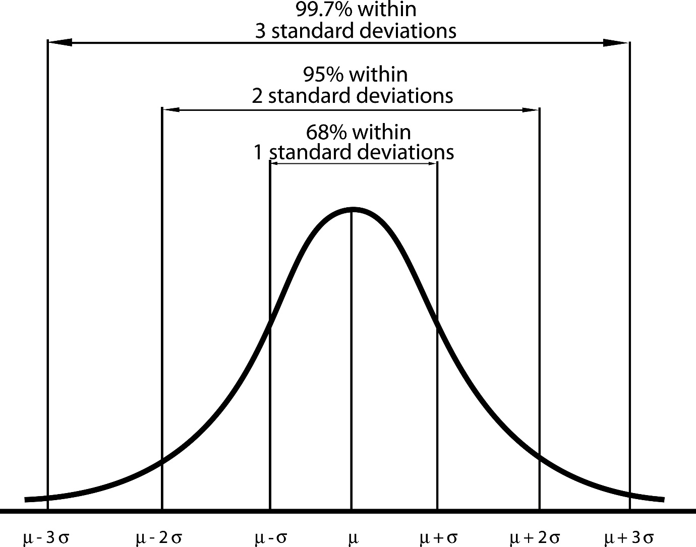
Shutterstock
A wider interval (larger ME) gives you higher confidence that you've captured the true population parameter, but the estimate is less precise. Conversely, a narrower interval (smaller ME) is more precise but comes with a lower confidence level (higher risk of missing the true parameter).

Q.5 Describe the purpose and assumptions of an ANOVA test. How does it extend hypothesis testing to more than two groups?
Ans. Here’s a clear and simple explanation:

Purpose of ANOVA (Analysis of Variance)
ANOVA is a statistical test used to compare the means of three or more groups to determine whether at least one group mean is significantly different from the others.
Why we use ANOVA?
- When we have more than two groups, using multiple t-tests increases the chance of Type I error (false positive).
- ANOVA controls this error and allows comparison in one single test.

Assumptions of ANOVA
ANOVA is valid only when the following assumptions are met:
1. Independence of observations
- Data of one participant or sample should not influence another.
- Usually ensured by proper random sampling.
2. Normality
- The data in each group should be approximately normally distributed.
3. Homogeneity of variance (Equal variances)
- The variances of all groups should be roughly equal.
- This is tested using Levene’s Test or Bartlett’s Test.

How ANOVA Extends Hypothesis Testing to More Than Two Groups
In a t-test
You compare only two means.
In ANOVA
You compare three or more group means simultaneously.
How it works:
- ANOVA separates the total variation in the data into:
  - Between-group variance (due to differences between group means)
  - Within-group variance (due to random variation inside groups)
- It then calculates the F-statistic = (Between variance) / (Within variance).
- A large F-value suggests that not all means are equal → at least one mean is significantly different.

Hypotheses in ANOVA
Null hypothesis (H₀):
All group means are equal
[
\mu_1 = \mu_2 = \mu_3 = \dots
]
Alternative hypothesis (H₁):
At least one group mean is different
Q.6 Write a Python program to perform a one-sample Z-test and interpret the result for a given dataset.
Ans. import numpy as np
from scipy.stats import norm

# -----------------------------
# Sample Data
# -----------------------------
data = [52, 55, 48, 50, 47, 53, 49, 51, 54, 50] # sample values
mu_0 = 50 # population mean (hypothesized)
sigma = 4 # population standard deviation (known)
alpha = 0.05 # significance level

# -----------------------------
# Z-test calculation
# -----------------------------
sample_mean = np.mean(data)
n = len(data)

# Z-statistic
z_stat = (sample_mean - mu_0) / (sigma / np.sqrt(n))

# p-value (two-tailed)
p_value = 2 * (1 - norm.cdf(abs(z_stat)))

# -----------------------------
# Results
# -----------------------------
print(f"Sample Mean: {sample_mean:.2f}")
print(f"Z-statistic: {z_stat:.3f}")
print(f"P-value: {p_value:.4f}")

# Interpretation
if p_value < alpha:
print("Result: Reject the null hypothesis (significant difference).")
else:
print("Result: Fail to reject the null hypothesis (no significant difference).")

Q.7 :Simulate a dataset from a binomial distribution (n = 10, p = 0.5) using NumPy and plot the histogram.
Ans. import numpy as np
import matplotlib.pyplot as plt

# Simulate data from a binomial distribution
n = 10
p = 0.5
size = 1000 # number of samples
data = np.random.binomial(n, p, size)

# Plot histogram
plt.figure()
plt.hist(data, bins=range(n+2))
plt.xlabel('Value')
plt.ylabel('Frequency')
plt.title('Histogram of Binomial(n=10, p=0.5)')
plt.show()

Q.8 Generate multiple samples from a non-normal distribution and implement the Central Limit Theorem using Python.
Ans. import numpy as np
import matplotlib.pyplot as plt

# ---------------------------
# Step 1: Generate non-normal data
# Using an exponential distribution (highly skewed)
# ---------------------------
population = np.random.exponential(scale=1.0, size=100000)

# ---------------------------
# Step 2: Draw multiple samples & compute sample means
# ---------------------------
sample_size = 50
num_samples = 1000
sample_means = []

for _ in range(num_samples):
sample = np.random.choice(population, sample_size)
sample_means.append(np.mean(sample))

sample_means = np.array(sample_means)

# ---------------------------
# Step 3: Plot histogram of population (non-normal)
# ---------------------------
plt.figure()
plt.hist(population, bins=50)
plt.xlabel("Value")
plt.ylabel("Frequency")
plt.title("Population Distribution (Exponential - Non Normal)")
plt.show()

# ---------------------------
# Step 4: Plot histogram of sample means (CLT)
# ---------------------------
plt.figure()
plt.hist(sample_means, bins=30)
plt.xlabel("Sample Mean")
plt.ylabel("Frequency")
plt.title("Sampling Distribution of the Mean (CLT Approx Normal)")
plt.show()

Q.9 Write a Python function to calculate and visualize the confidence interval for a sample mean.
Ans. import numpy as np
import matplotlib.pyplot as plt
from scipy.stats import norm

def plot_confidence_interval(data, confidence=0.95):
# Calculate statistics
sample_mean = np.mean(data)
sample_std = np.std(data, ddof=1)
n = len(data)

# Z-critical value
z_critical = norm.ppf((1 + confidence) / 2)

# Margin of error
margin = z_critical * (sample_std / np.sqrt(n))

# Confidence interval
lower = sample_mean - margin
upper = sample_mean + margin

# Visualization
plt.figure()
plt.axvline(sample_mean, linestyle='--')
plt.axvspan(lower, upper, alpha=0.3)
plt.hist(data, bins=20)
plt.xlabel("Value")
plt.ylabel("Frequency")
plt.title(f"Confidence Interval for Sample Mean ({confidence*100:.1f}%)")
plt.show()

return sample_mean, (lower, upper)

# Example usage
np.random.seed(0)
sample_data = np.random.normal(loc=50, scale=10, size=200)
plot_confidence_interval(sample_data, confidence=0.95)

Q.10 Perform a Chi-square goodness-of-fit test using Python to compare observed and expected distributions, and explain the outcome.
Ans. import numpy as np
from scipy.stats import chisquare

# Observed frequencies (example)
observed = np.array([25, 30, 20, 25])

# Expected frequencies (uniform distribution)
expected = np.array([25, 25, 25, 25])

# Perform Chi-square goodness-of-fit test
chi_stat, p_value = chisquare(f_obs=observed, f_exp=expected)

chi_stat, p_value

